# Jr - HTML / CSS Code Challenge

**TASK:**

Build an HTML page from the attached PSD / JPG file below . All assets are provided. Build the page using HTML, CSS and Javascript only.

Start with the HTML Boilerplate here: <https://html5boilerplate.com/>

Add Font Awesome font reference to the page : [https://fontawesome.com](https://fontawesome.com/)

Add Bootstrap reference to the page: <https://getbootstrap.com/>

Add Google Font **Roboto** to page:<https://fonts.google.com/>

Use the bootstrap grid layout to manage the layout on your page

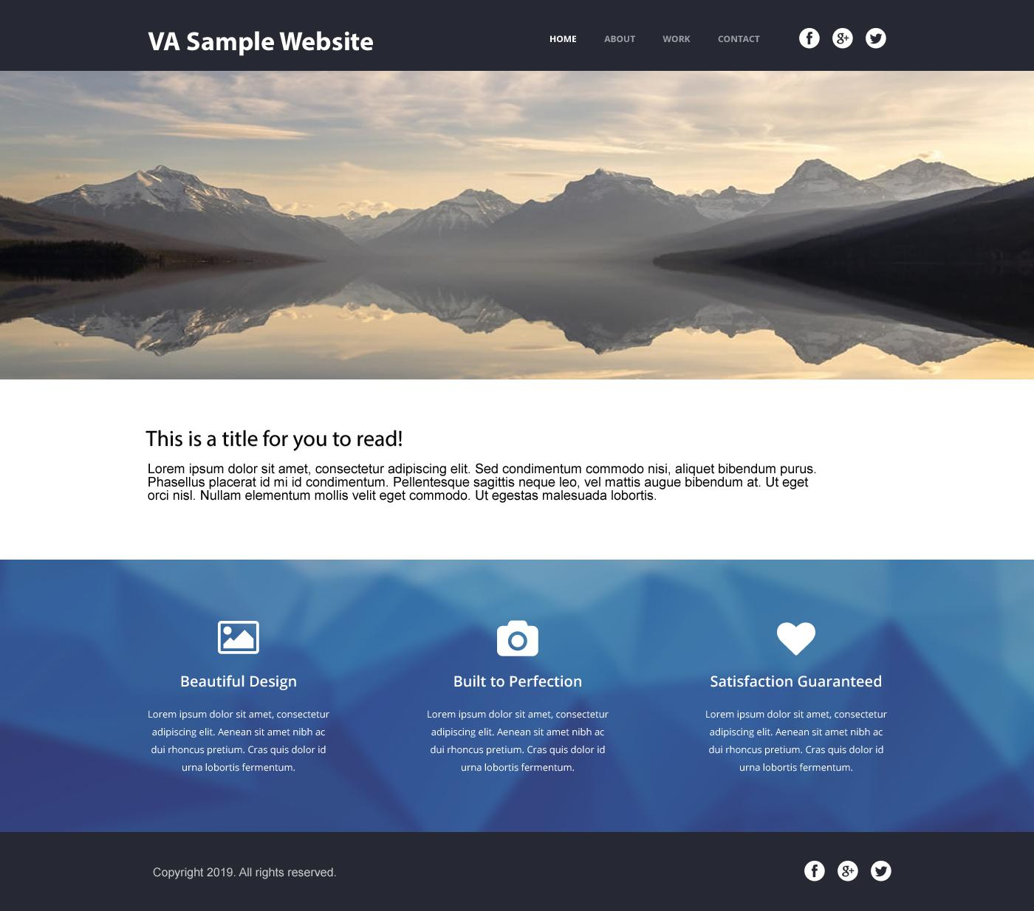

This project does not require photoshop. The page can be built using the assets provided and the JPG screenshot as a guide.

**JPG ScreenShot:**

<https://drive.google.com/file/d/1mC_jegbzrpZQsGWyv80gOg8JLY5vuRC5/view?usp=sharing>

**Assets:** <https://drive.google.com/file/d/1xg_GcwK4OgoeNxSmISoE0DXZkSn0Jlml/view?usp=sharing>

**PSD File:**

<https://drive.google.com/file/d/1X9T0JSWVwQfbGfD2R5JJJdhbLppsi5DJ/view?usp=sharing>

**Deliverables:**

We require a working standalone web page implementation of the provided design. All files should be provided and packaged in a zip file.

**Submission:**

Zip all of your project files into one zip folder and upload them to the dropbox here:

<https://www.dropbox.com/request/MgIxPPwJwVVctfNHU9sK>

Send an email to [hr@visualantidote.com](mailto:hr@visualantidote.com) and confirm you have uploaded your challenge. Make sure to email them before the due time, otherwise it will lead to automatic disqualification. No exceptions will be made.

**Bonus**:

Create a free account on Netlify ( <https://www.netlify.com/> ) if you do not have one already. Deploy your project to your Netlify account . Get link of deployed project and send with your submission.

deployment link should look similar to this:

<https://nifty-lalande-e15d84.netlify.com/>